ASSIGNMENT AR VR

Task 1 :- SET UP UNITY PROJECT

Steps:-

Open unity

download xr interaction tool kit

Screenshot:-

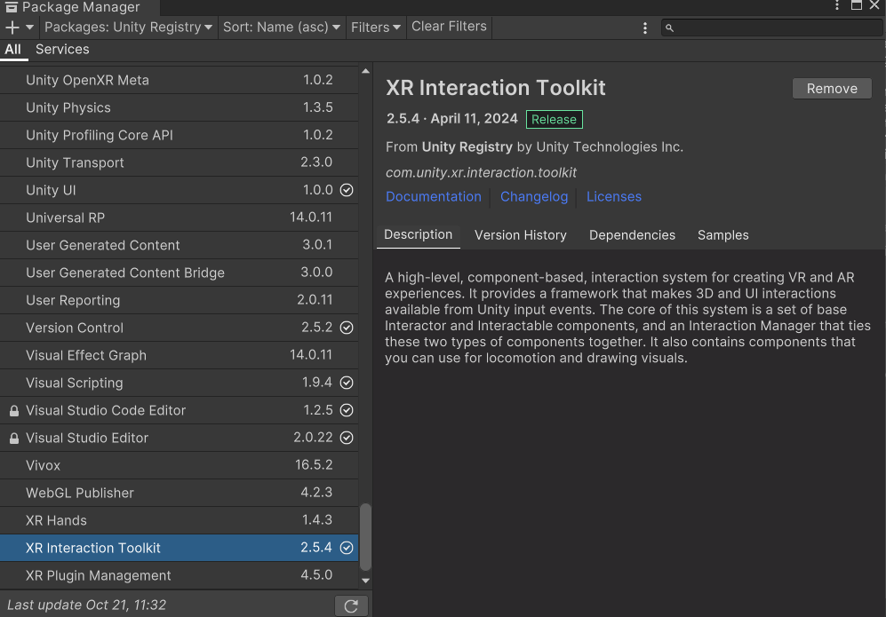

TASK 2:- CREATING ENVIRONMENT

Steps:-

create environment

Import environment from asset store

Download it in unity

Screenshot:-

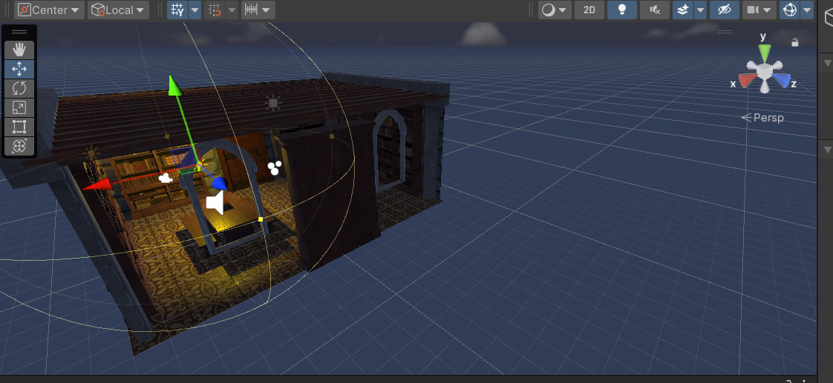

TASK 3:- ADD SKYBOX

Steps:-

Import from asset store

Download it in unity

Screenshot:-

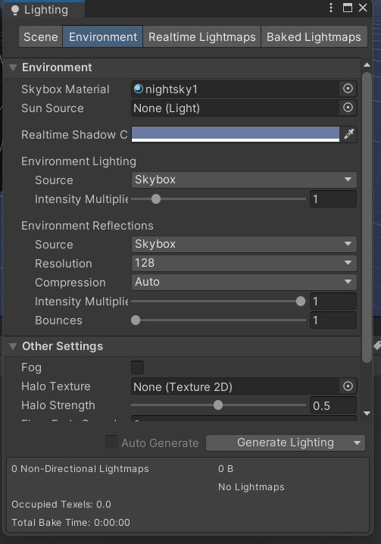

Task 4:- Add Environment Objects:-

Steps:-

Using book as an environment object

Add book in scene

Trying to pick the book

Screenshot:-

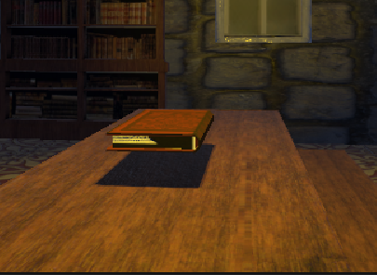

TASK 5:- LIGHTING AND SHADOWS

Steps:-

Add point light above the table

Set the range and itensity accordingly

Selecting hard shadows for shadow

Screenshot:-

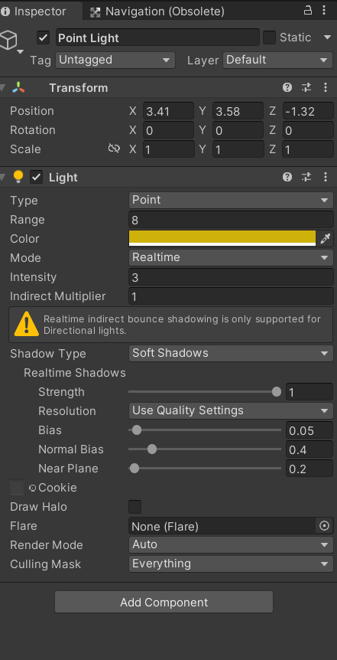



TASK 6:- AUDIO

Steps:-

Get any any audio from online

Import in unity

Create new game object

In audio add component audio source

Screenshot:-

